Daniel Fryer
Assignment 5.2
9/11/2026

For this assignment I decided to look at my wife’s and mine lunch meal prep for the week. Currently on Sunday’s we plan, shop, cook, and package lunches for our upcoming week.

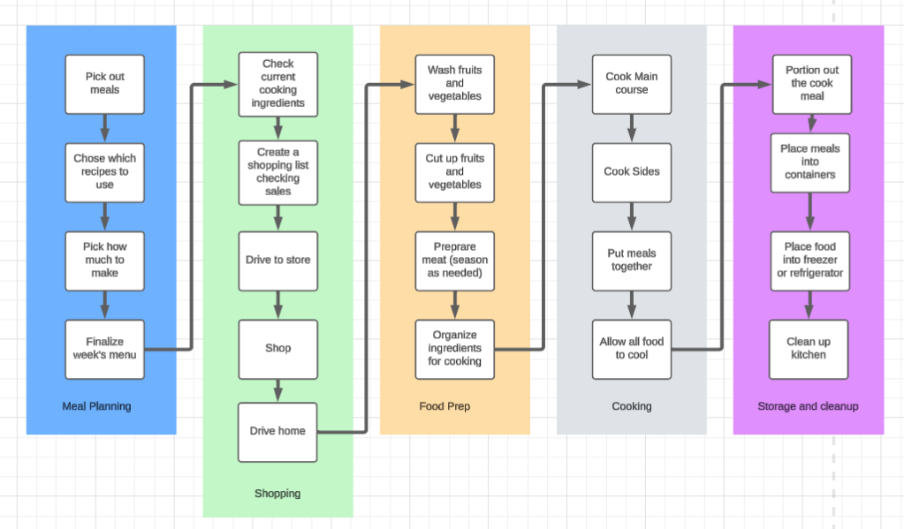

Meal Planning | 30 Mins
Shopping | 120 Mins
Food Prep | 45 Mins
Cooking | 60 Mins
Storage and cleanup | 60 Mins
TOTAL | 315 Mins

While looking at my value stream there are quite a few places I can change to reduce the total time. There are a few places I can speed up and improve on the 5.25 hours of meal prep we estimated we do each Sunday.
- Waste Elimination – Instead of picking out new recipes each week make a group of 25 to 50 cards that contain recipes we enjoy so we are not picking or flipping and can’t decide. I think we can save ~20 min doing it this way. Next place we can eliminate waste is the shopping. If we pick out the next week’s meals, we can have Walmart deliver our ingredients we would need for the prep Sunday morning. So, without needing to drive and find the items myself I estimate a savings of 90 minutes.
- Workflow Orchestration – I think we could move the Clean up kitchen to be between the cooking and storage stage. Instead of relaxing after cooking and coming back we could clean the kitchen while we wait for the food to cool. If we look at purchasing more glass containers, we could reduce the need to waiting for most of the food to cool off and not worry about our plastic containers warping.
- Governance Models – The wife and I could create a standard process we follow each week for meal prep. An example would be if we decide by Saturday afternoon, we can place our grocery order and have it delivered Sunday morning. We could also keep an inventory of our ingredients and note which common ones we need or add them to the list as they run out. With these rules we might have a better chance of not having an ingredient we need once we start to cook.

In conclusion this gave the wife and me a chance to look at and reduce the time we spend on making our lunches for the week ahead. Our original process has us taking approximately 315 minutes or 5.25 hours each Sunday morning doing our lunch prep. If our estimates below line up how we think they will it will save us an estimated 140 minutes or 2.3 hours which is a 44% reduction if time we spent on meal preps.
Meal Planning | 10 Mins
Shopping | 30 Mins
Food Prep | 45 Mins
Cooking | 60 Mins
Storage and cleanup | 30 Mins
TOTAL | 175 Mins

Biggest and best improvement is on the shopping reducing our trip to the stores after church and fighting the crowds will be the biggest time saver. Moving some of the tasks like clean up around even though its nice to relax after prep and cooking overall it will give us more time back during the day.

